**Report on ElectroMega**

**An E-Commerce Electronics Shopping Website**

By,

Avinash Kumar

2110991887

G5 - 3rd Year

Faculty - Mr. Lavish Arora

# Contents

Our website comprises 20 pages, each serving a specific purpose:

* Landing Page
* Comparison
* Categories
* Broad Categories
* Product Review
* Product Page
* Store Locator
* Gift Cards
* ElectroMega Foundation
* Checkout
* FAQ
* Affiliate Program
* Affiliate Tools
* Customer Services
* Blog
* Track Order
* About Us
* Contact
* Login
* Signup

# Introduction

The Introduction page of ElectroMega serves as the digital storefront's welcoming entrance. This crucial first impression is a product of HTML, CSS, JavaScript, and Bootstrap working in harmony. HTML provides the page structure, while CSS ensures a visually appealing design, making it inviting to visitors. JavaScript adds interactive elements, facilitating a smooth user experience. Bootstrap's responsive framework adapts the page to different devices, enhancing accessibility. Together, these technologies create a compelling Introduction page that captivates visitors, guiding them into the world of electronics available at ElectroMega.

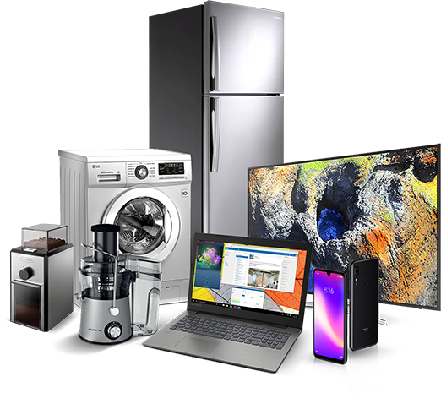

# Overview

The ElectroMega website boasts a cohesive and user-friendly page structure, offering a seamless experience to visitors. Central to this structure is the consistent presence of a navigation bar and footer across all web pages.

Navigation Bar:

Every page on the ElectroMega website features a well-designed and intuitive navigation bar, positioned strategically for easy access. This navigation bar serves as a vital tool for users to effortlessly navigate through various sections and pages of the website. The key feature of this navigation bar is the "All Pages" button, which offers direct access to different sections, enhancing user convenience. Whether you wish to explore categories, seek information about the company, or engage in charitable activities, the navigation bar provides the gateway.

Footer:

Complementing the top navigation bar is the footer, which appears consistently on every page. This footer is designed to enhance user experience and convenience further. It includes a set of links, ensuring that users can quickly find their way to essential information, such as the privacy policy, terms and conditions, and more. This section offers an additional layer of navigation, providing access to valuable resources and important documents that users might require.

This cohesive and uniform design approach, featuring a navigation bar with an "All Pages" button and a footer with links, ensures that users can efficiently and intuitively explore the entirety of the ElectroMega website. This consistency in design and functionality contributes to a user-friendly experience, making it easy for visitors to find what they need and move between different sections of the website.

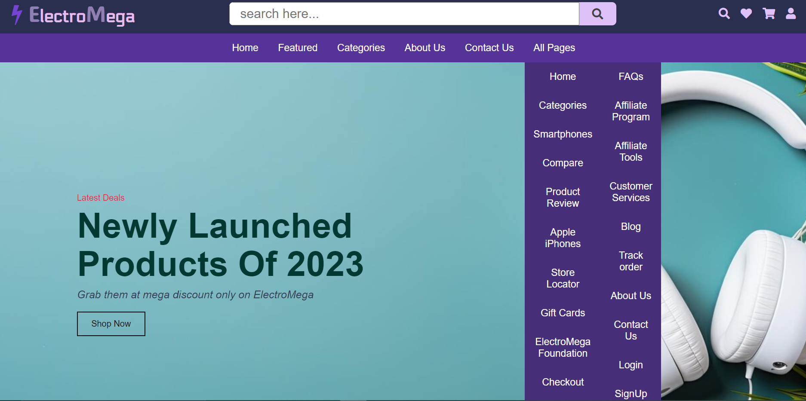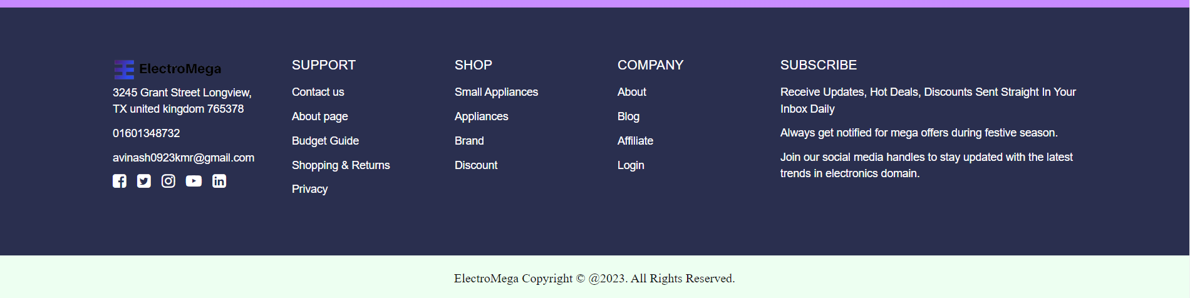

# Landing Page

Home Page include the showcase of latest arrivals of electronic items such as fridge, washing machine, TVs etc.

The page has also the use of carousel to showcase various offers on products.

CODE:

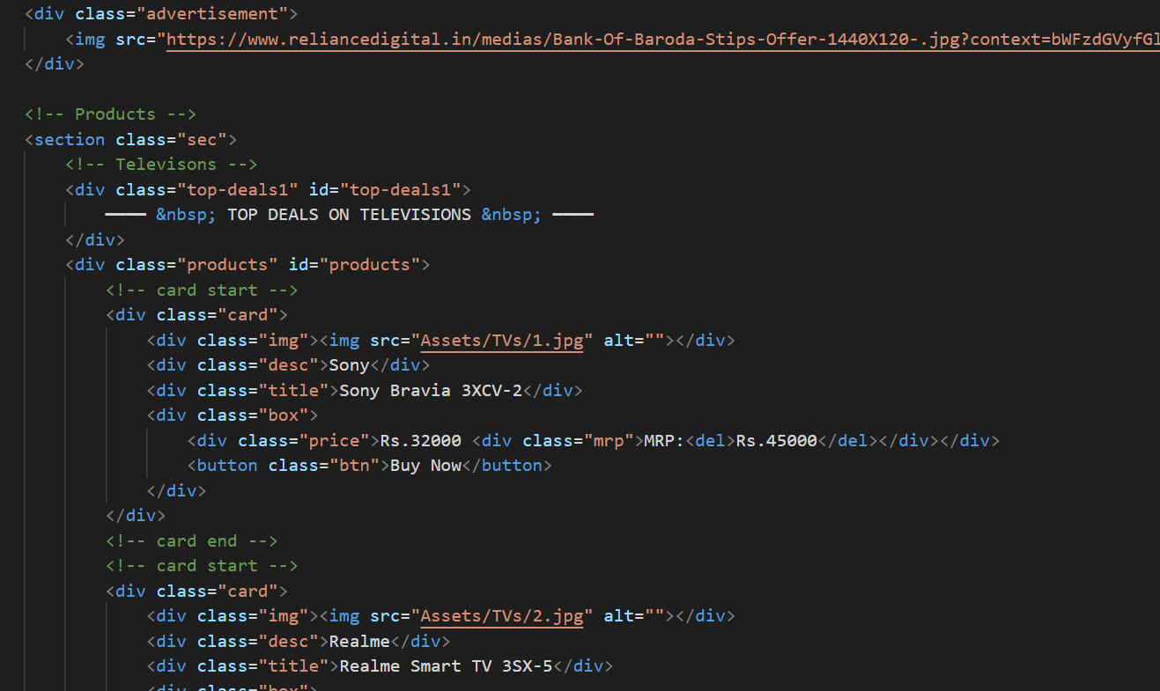

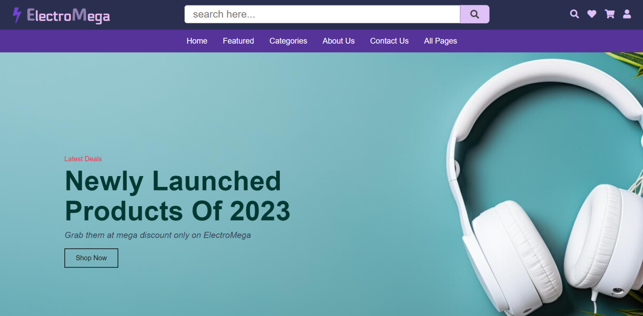

# Categories

The Categories page is a hub for exploring electronic products, where users can shop by brand or category. It's powered by HTML for structural elements, CSS for styling, JavaScript for dynamic filters, and Bootstrap for responsiveness. HTML organizes the content, while CSS makes it visually appealing. JavaScript adds interactive features, enabling users to filter products seamlessly. Bootstrap ensures the page's adaptability to various devices. Together, these technologies deliver a user-friendly, visually appealing, and responsive Categories page, simplifying the shopping experience.

CODE:

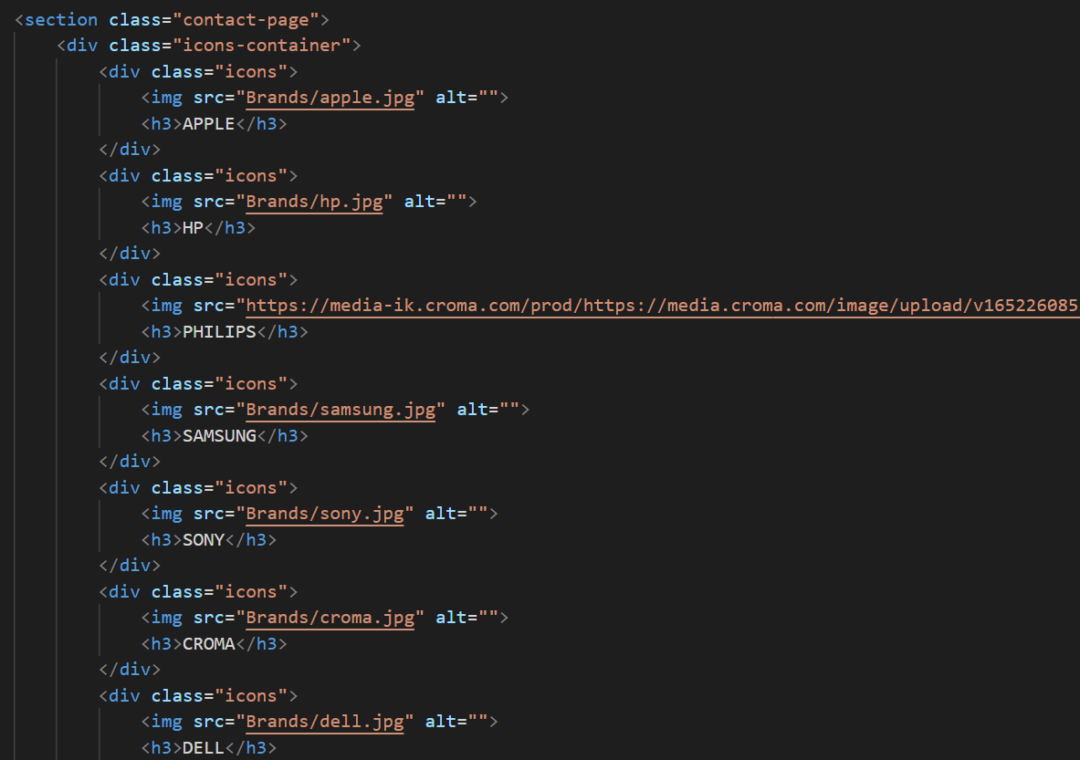

# Broad Categories (Smartphones)

The Broad Categories page, focusing on smartphones, is a subset of the Categories page. HTML structures the content, CSS styles it, and JavaScript enhances interactivity. Users can select smartphones based on specific use cases such as gaming or photography, which is facilitated by JavaScript. The responsive design is achieved through Bootstrap, ensuring an optimal user experience on any device. This page streamlines the smartphone shopping process, offering an engaging and user-friendly interface.

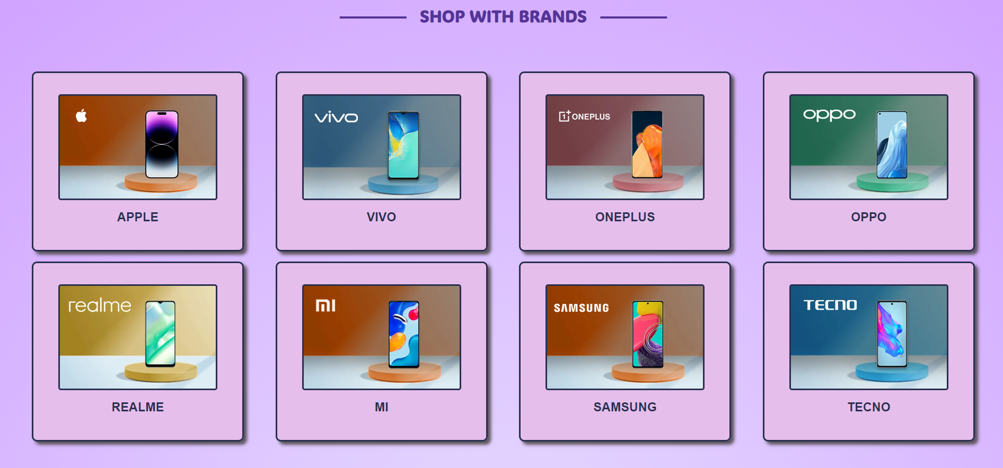

# Store Locator

ElectroMega's Store Locator page employs HTML, CSS, JavaScript, and integrates the Google Maps API. HTML structures the page, CSS adds styling, and JavaScript enhances interactivity. The Google Maps API integration facilitates location searches. Users can effortlessly find the nearest ElectroMega store, making physical shopping more convenient. This page offers an essential service to users, combining the power of HTML, CSS, JavaScript, and the Google Maps API to ensure accessibility and user satisfaction.

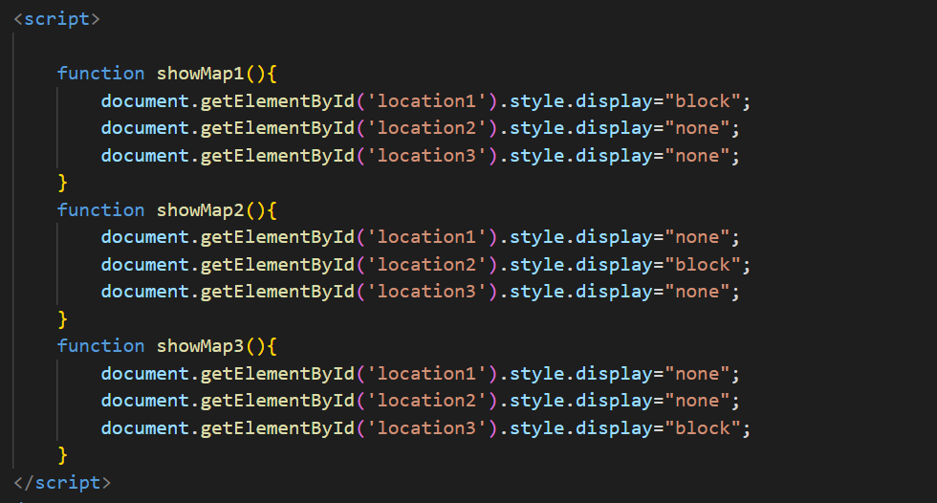

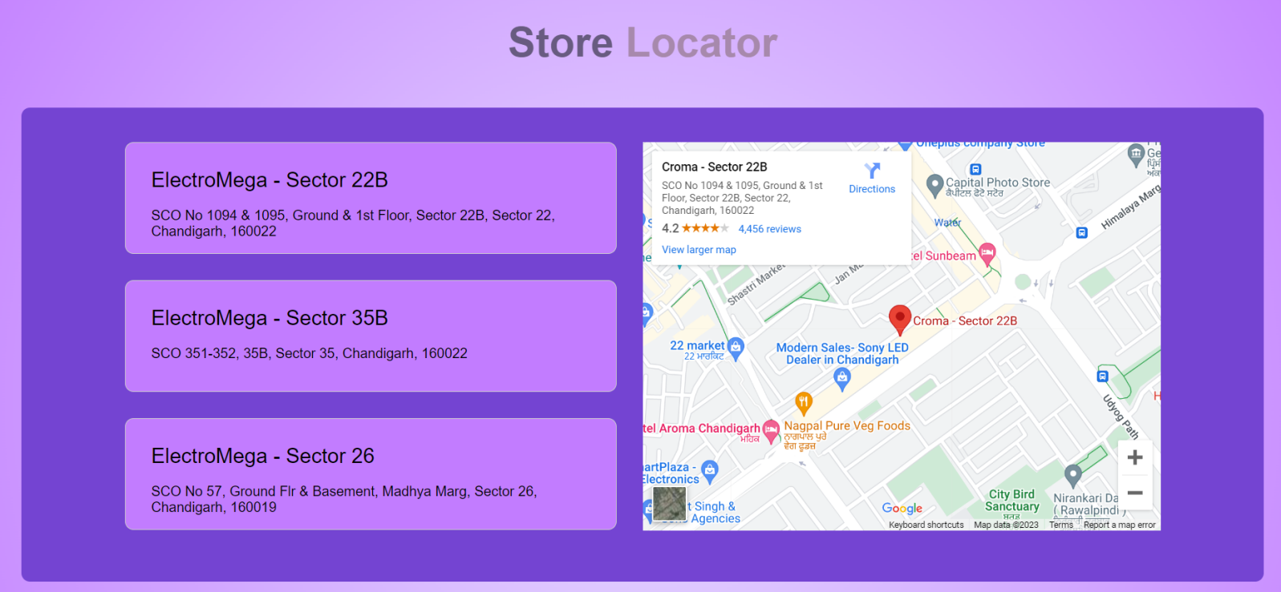

# Gift Card

The Gift Card page is powered by HTML and CSS for structure and design. JavaScript is utilized to enable gift cards to generate receipts. This feature adds convenience for both gift givers and receivers, enhancing the overall user experience. The combination of these technologies provides an easy and efficient platform for purchasing and managing gift cards on ElectroMega.

CODE:

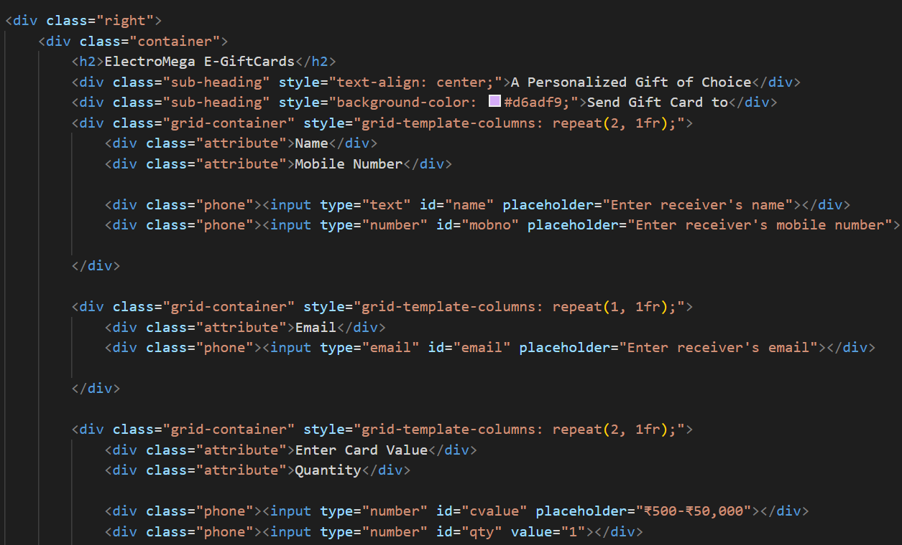

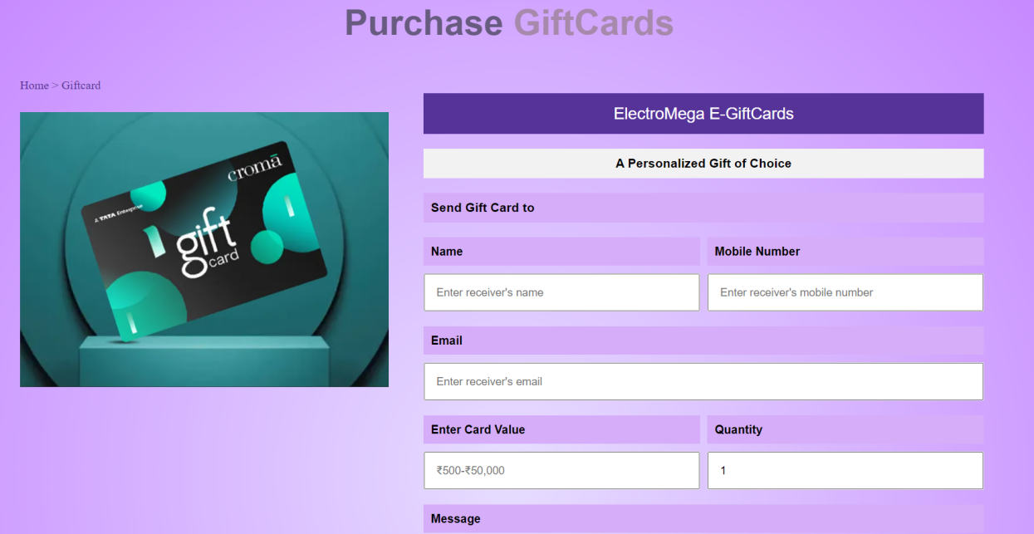

# Foundation Page

The ElectroMega Foundation page, designed using HTML, CSS, JavaScript, and Bootstrap, allows users to enter any amount and date for charitable donations. HTML structures the content, CSS styles it, while JavaScript manages the input for charitable contributions. Bootstrap ensures the page's responsiveness. This philanthropic feature enriches the user experience and aligns ElectroMega's technology with a commitment to positive social impact.

CODE:

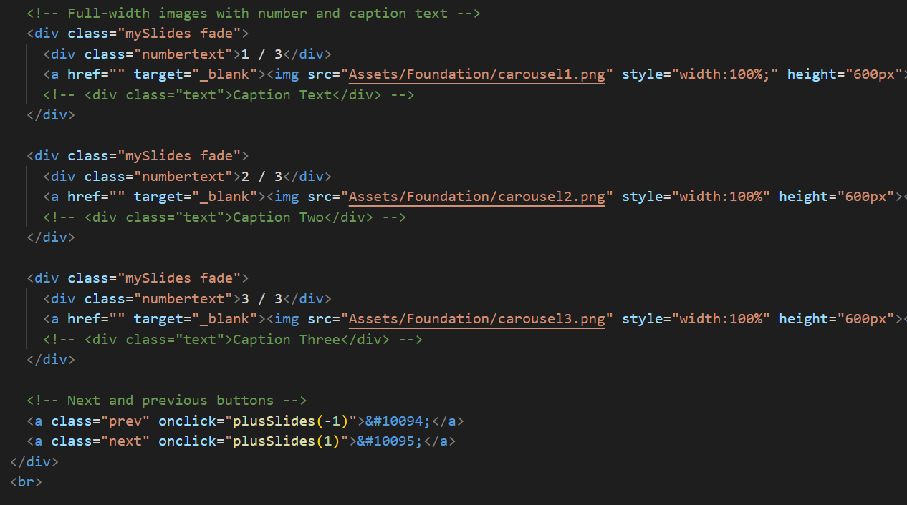

# Checkout Page

The Checkout page simplifies the purchasing process using a combination of HTML, CSS, and JavaScript. HTML structures the page, CSS provides a visually pleasing design, and JavaScript handles secure and efficient transactions. This ensures a seamless and secure user experience, reducing friction during the final step of a transaction.

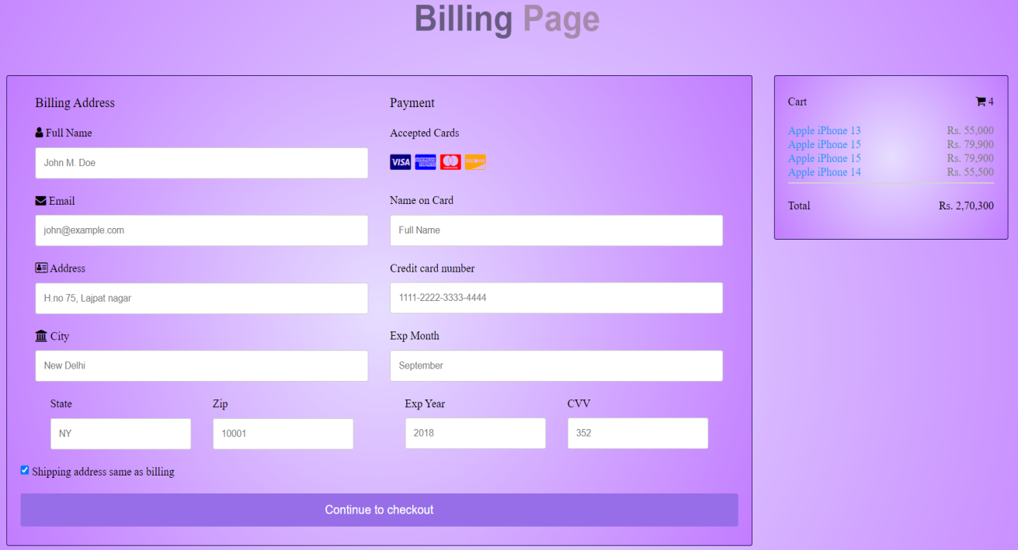

# FAQ Page

The FAQ page is structured with HTML and styled with CSS. JavaScript is applied to enable users to expand and collapse FAQ sections for easy navigation. This page offers solutions to common questions, enhancing the user experience by providing quick access to information.

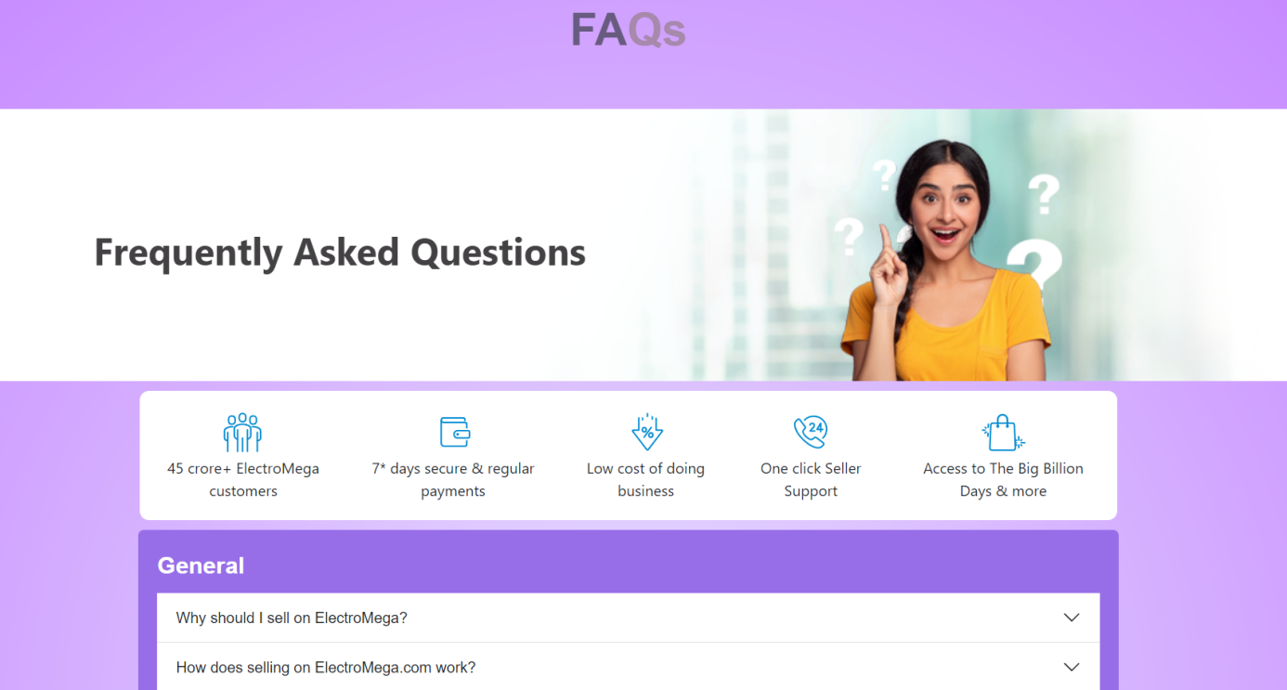

# Affiliate Program Page

The Affiliate Program page employs HTML, CSS, JavaScript, and Bootstrap. It offers information about the program and allows users to sign up and access affiliate tools using JavaScript. The combination of these technologies facilitates a user-friendly experience for potential affiliates, promoting transparency and ease of use.

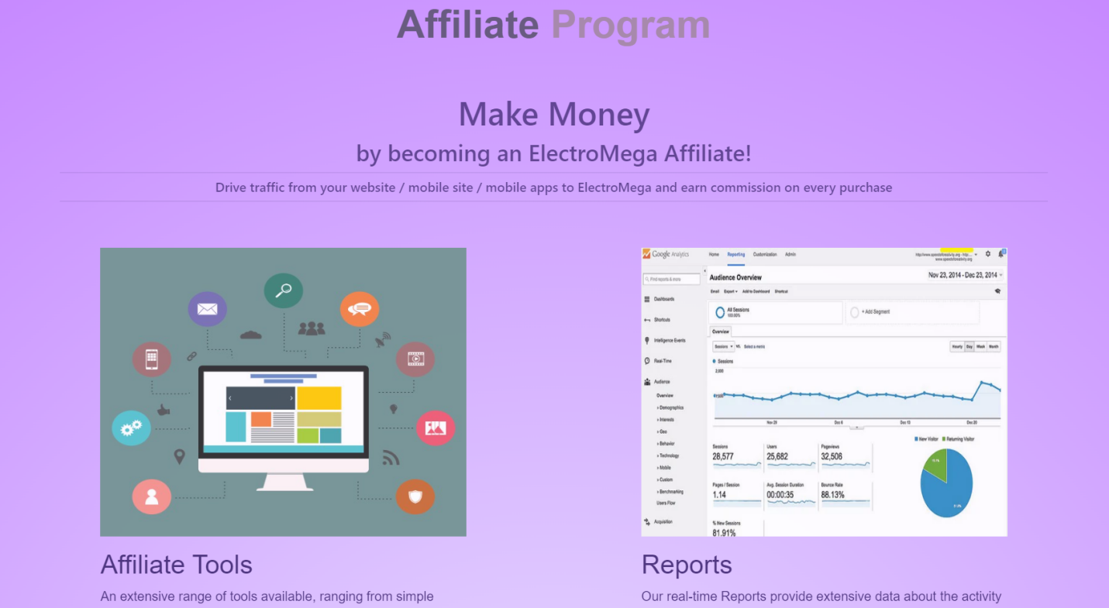

# Customer Support Page

The Customer Support page is built with HTML, CSS, and JavaScript. It provides various contact options, including phone, email, and live chat. These technologies ensure responsive and user-friendly support, enhancing the overall user experience.

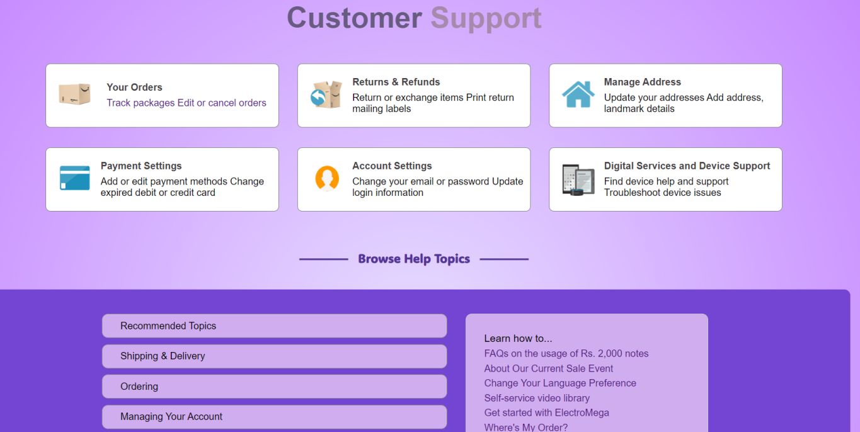

# Blog page

The Blog page is powered by HTML, CSS, and JavaScript. It features articles and content about electronics, offering informative and engaging content to users. HTML structures the content, CSS enhances its visual appeal, and JavaScript adds interactive features.



# Order Tracking Page

The Order Tracking page uses HTML, CSS, and JavaScript to enable real-time order tracking, enhancing user transparency and convenience. This page simplifies the order tracking process, making it efficient and straightforward for users.

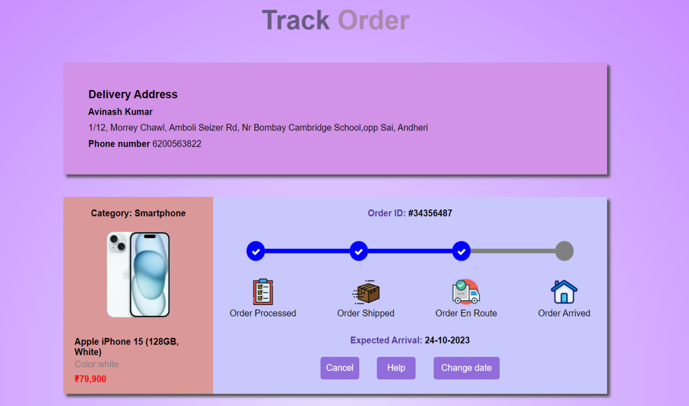

# About Page

The About Us page is designed using HTML, CSS, JavaScript, and Bootstrap. It shares the company's mission, values, and history. HTML structures the content, CSS ensures visual appeal, and JavaScript and Bootstrap enhance the page's interactivity and responsiveness. It offers users insights into the company's background and values.

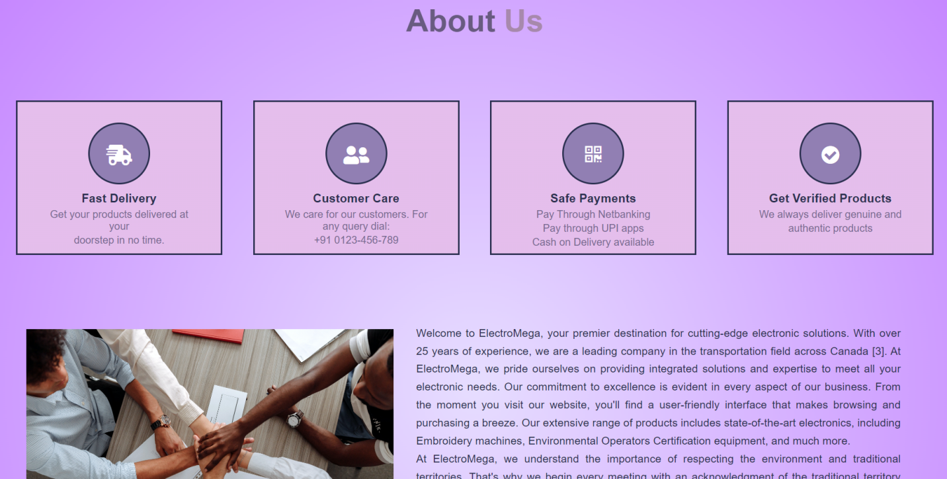

# Contact Us

The Contact Us page is developed with HTML, CSS, and JavaScript, offering multiple communication channels for users to reach out for assistance. These technologies facilitate a responsive and user-friendly support experience.

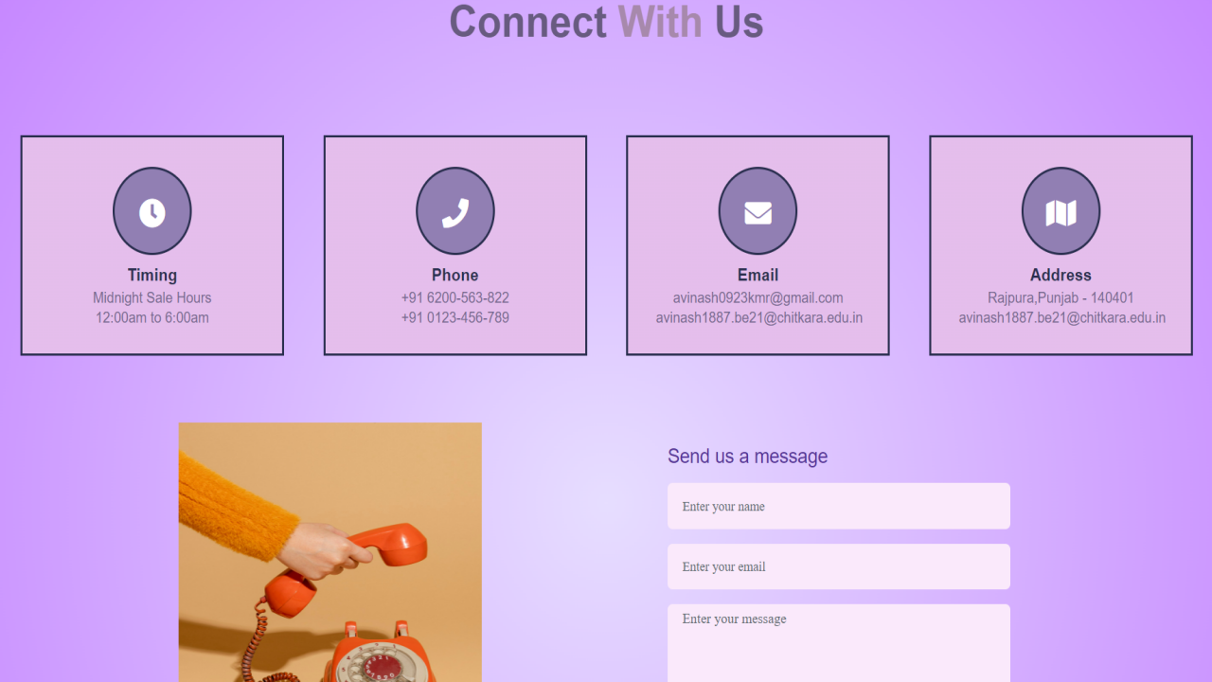

# Login Page

The Login page is created with HTML, CSS, and JavaScript to secure user accounts, allowing efficient authentication and access to personalized features. It simplifies the login process for users, enhancing their overall experience.

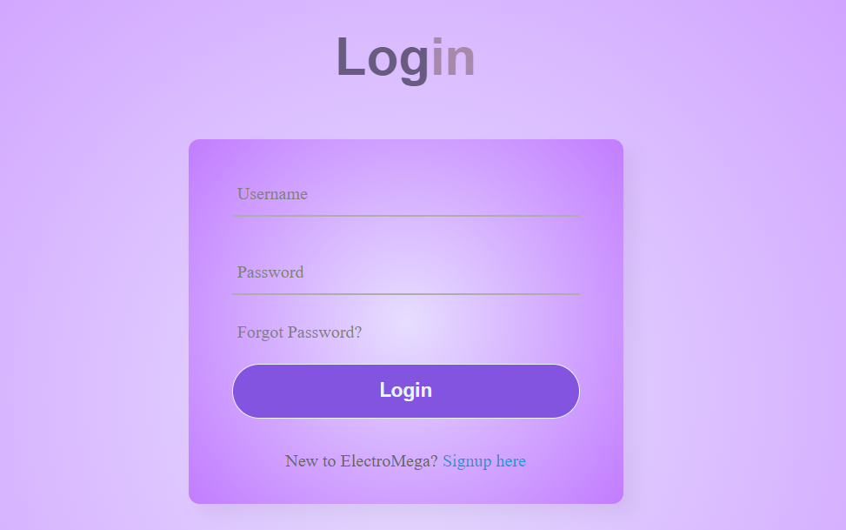

# Sign Up Page

The Sign Up page utilizes HTML, CSS, and JavaScript to enable users to create accounts, offering access to exclusive features and personalization options. It simplifies the registration process, making it user-friendly and efficient

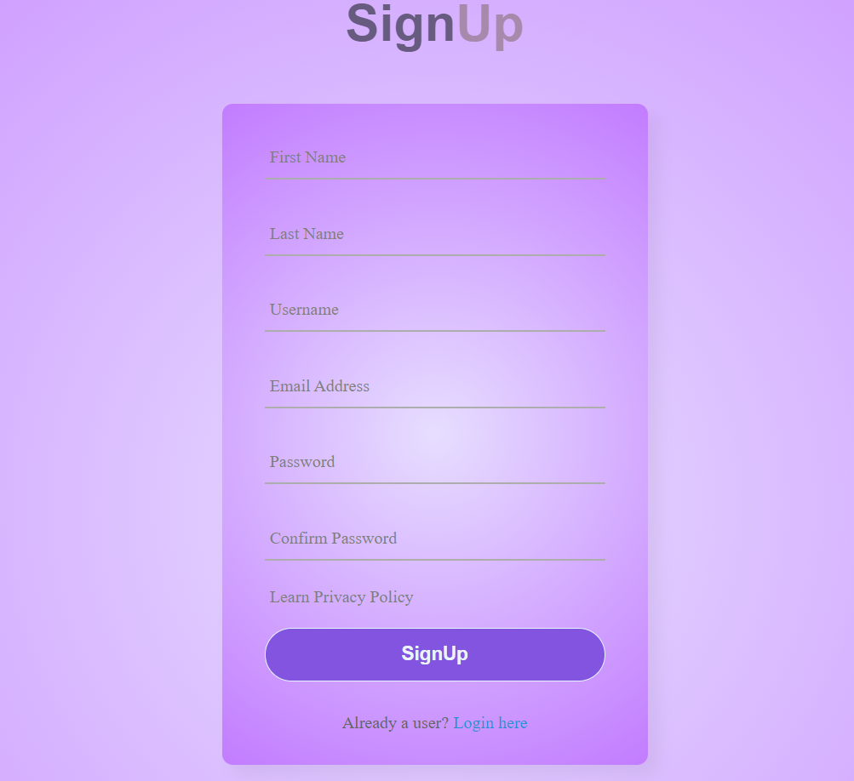

# Conclusion

In conclusion, ElectroMega is a dynamic and user-centric electronics shopping platform, where every aspect has been meticulously designed to provide a seamless and enjoyable experience. From the sleek and responsive design to the extensive range of products, our website is built on a foundation of cutting-edge technologies, ensuring accessibility and convenience.

The navigation bar, featuring the "All Pages" button, serves as a central hub for users to explore the diverse sections of the website. Whether you're searching for specific products, information about our charitable initiatives, or the latest in tech trends, this feature simplifies your journey.

Additionally, our consistent footer, with its array of useful links, further enhances the user experience by providing quick access to essential resources and policies. This approach to website design ensures that you're never far from the information you need.

At ElectroMega, our commitment to user satisfaction extends beyond the products we offer. It's embedded in every aspect of our website's design and functionality. We're dedicated to making your electronics shopping not just efficient but also enjoyable.

Thank you for choosing ElectroMega as your trusted electronics partner. We look forward to providing you with the best in electronics and an unparalleled online shopping experience. Your tech journey begins here!